**PROJECT REPORT**

**Of**

A Desktop software for helping Flood affected people to be used at flood relief camp.

**Submitted by:**

1. Deepam Chetry, 12008097, R.no 03, K20TS
2. Somya Ranjan Sahu, 12008793, R.no 43, K20TS

**Submitted to:**

Pooja Rana Mam

**School of Computer Sciences and Engineering**



**ABSTRACT**

Our software will be used by mainly flood relief shelters during the

period of ongoing disaster to monitor data of lost people, to provide

shelter to the victims of the flood, to keep check on the supplies in stock for prolonged survival of the refugees.

We have total 5 modules in this software, they are:

1) Home Interface

2) Donation

3) Helpline

4) Safety Measures

5) Current Status

We are working on developing a database frame that can store and delete current flood records of different regions. State, relief centers, deaths and total donations are being stored in the record of the database.

We are working on a way to reach out to people via call, mail, or chat. Safety measures and all necessary precautions and guidelines are being provided to have control on the situation . Donation module is being provided to those who want to help the needy.

**INTRODUCTION**

**What is flood?**

A **flood** is an overflow of water that submerges land. Floods are natural occurrences where an area or land that is normally dry abruptly is submerged in water.

**Effects of floods**

Flood has been considered as one of the most recurring and frequent disaster in the world. India also has continuously suffered by many flood events which claimed huge loss of life and economy.

**Recent floods**

A series of floods took place across the Indian state of Maharashtra in 2021. As of 28 July 2021, around 251 people have died and over 100 are still missing due to floods.

With 298 deaths and 66 reported missing in weather-related disasters in 2021, the year has turned out to be the second-worst in terms of loss of lives in such [calamities](https://timesofindia.indiatimes.com/topic/calamities) after 2013 when Kedarnath [flash floods](https://timesofindia.indiatimes.com/topic/flash-floods) had taken thousands of lives.

**ROLE OF TEAM MEMBERS**

1. **Deepam Chetry –** Home interface, Donation module, Current Status( Deletion ).
2. **Somya Ranjan Sahu –** Helpline module, Safety Measures, Current Status.

**LIBRARIES USED**

**For Database management**

**MYSQL -** for collection and analysis of data

MySQL is a Relational Database Management System or RDBMS which means that it stores and presents data in tabular form, organized in rows and columns.

MySQL is more secure as it consists of a solid data security layer to protect sensitive data from intruders and passwords in MySQL are encrypted.

**For Graphical User Interface (GUI)**

**Tkinter -** to create GUI

Tkinter is the standard GUI library for python when combined with Tkinter provides fast and easy way to create GUI applications. Tkinter provides a powerful object-oriented interface to the Tk GUI toolkit. Add one or more of the above-mentioned widgets to the GUI application.

**PROPOSED MODULES**

**The GUI home Interface Module**

It contains all the info about the various sub modules which acts as a key factor for directing into the other interface window performing various tasks.

**The donation module**

It gathers the information about the person willing to donate a certain amount creating a helping hand for the flood effected people.

This module collects and stores the sender’s information such as the name, address, gender, Ph.no, Payment mode and the amount he/she is willing to donate.

**The Helpline Module**

It offers a wide variety of help options depending upon the help the user is looking for.

There are a set of help options namely call, mail, chat support and we have provided an extra helpline number and email which can help user reach us directly.

**The Safety Measures Module**

In this module it contains a set of safety instructions that are to be followed during such critical situation.

We have also provided our instant helpline number for emergency purposes too.

**The Current Status Module**

This module shows the current status of the flood affected region with total number of deaths, centers, and donations till date.

Each record is identified with their id numbers(1,2,3…).

Status records are displayed and deleted in the database though “Show record” and “Delete record” buttons. MySQL handles all the database works here.

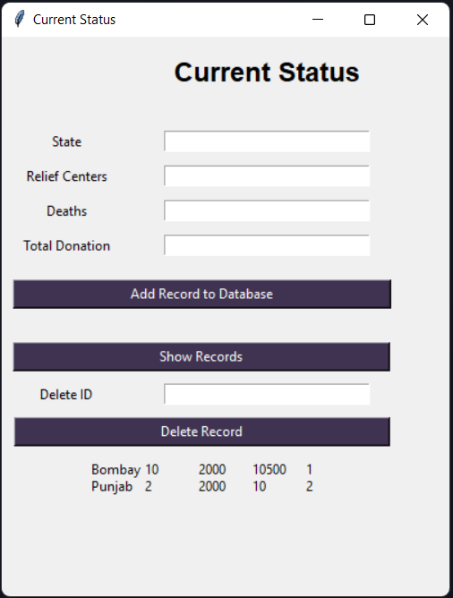

**Conclusion**

It is our team’s hope that this document will be of huge help with understanding of our little project as we have used a different approach which has proved beneficial for us. Such kind of software and with little more modification can really be of great help in practical world.

All the basics of Tkinter and sqlite3 have been implemented in the project to show their practical use.

**References**

1. <https://docs.python.org/3/library/tkinter.html>
2. <https://www.geeksforgeeks.org/python-gui-tkinter/>
3. <https://dev.mysql.com/doc/>
4. <https://www.redcross.org/about-us/our-work/disaster-relief/flood-relief.html>
5. <https://pmnrf.gov.in/en/>
6. https://www.youtube.com/